ARITHMETIC PROGRESSION EXERCISE- 5.2 MODULE-2/5

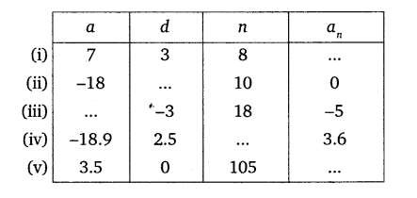
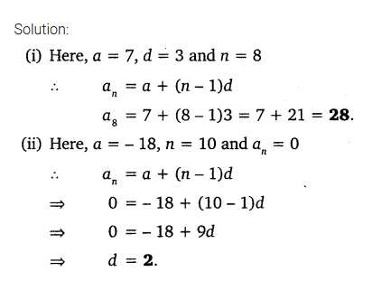
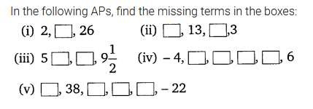
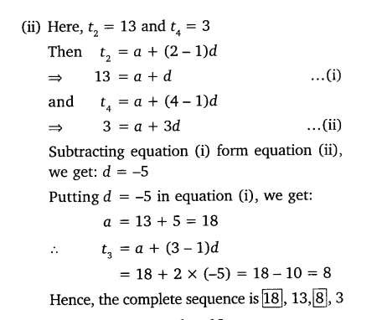
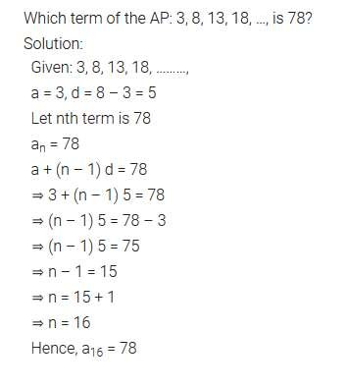

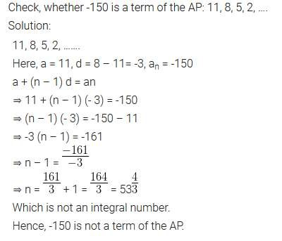
Find the 31st term of an AP whose 11th
term is 38 and the 16th term is 73.
Solution:
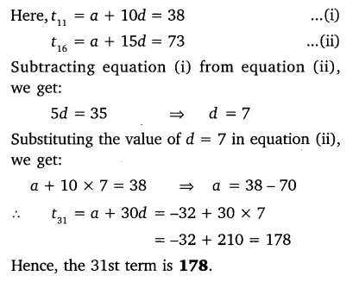

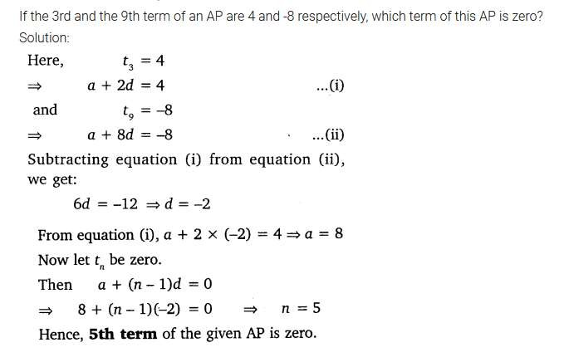
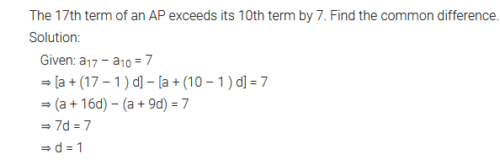
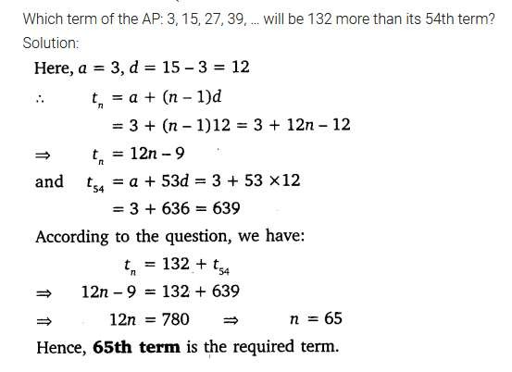

Two APs have the same
common difference. The difference between their 100th terms is 100, what is the difference between their 1000th terms?
How many multiples of 4 lie between 10 and 250? Solution:

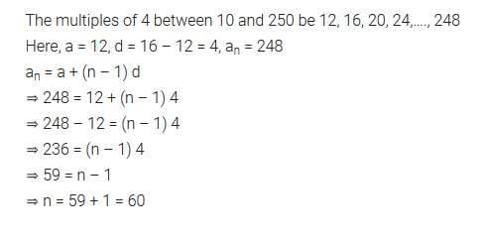

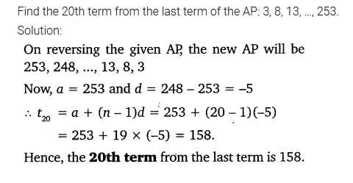
The sum of the 4th and 8th terms of an AP is 24 and the sum of the 6th and 10th terms is 44. Find the first three terms of the AP.
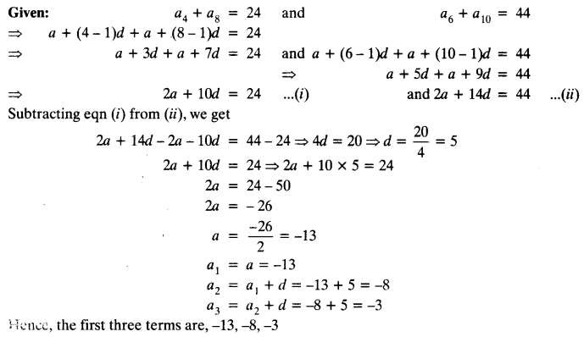

Subba Rao started work in 1995 at an annual salary of ₹ 5000 and received an increment of ₹ 200 each year. In which year did his income reach ₹ 7000 ?
Solution:
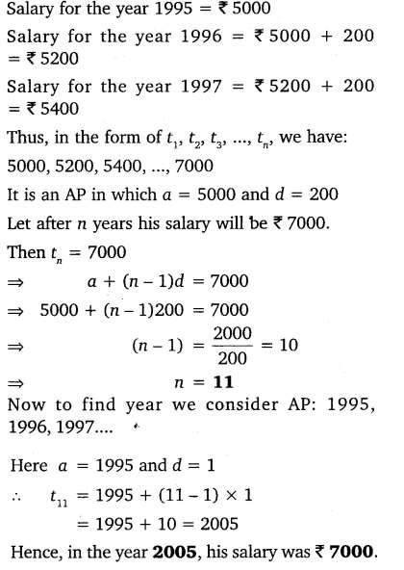

THANK YOU!!!!!!!

